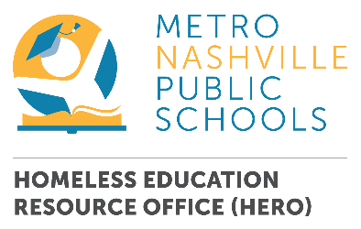

HERO Pantry Partner Grocery List

Thank you for being our HERO! Items in our pantry serve families in housing situations that often mean little-to-no kitchen access – hotel living, doubled up with another family, or in a shelter where meals are scheduled - so we’ve worked with parents and caregivers to build a list of items that would be most welcome and impactful. We have had recent requests for items that are more stove-friendly from our families who have recently secured housing (yay!), so the list has changed a bit in the last few months. Note: The overlying theme of these items is “kid-friendly” and “one and done” - nothing much more than a microwave and water needed to make a quick meal or snack. (Current greatest needs and new additions have an *)

- Mac and Cheese – single serve and boxed
- Pop-Top Chef Boyardee or other pasta meals
- Tuna or Chicken salad kits – in vacuum-sealed pouches with mix-ins and crackers
- Canned Chicken Breast *
- Hearty soups in individual microwavable bowls
- Shelf-stable microwavable meals (often found near Mac N Cheese. Brands - Hormel, Kraft, Velveeta)
- Microwavable cups of vegetables (Libby offers these)*
- Cans of vegetables
- Pre-Cooked pasta pouches (Barilla brand offers this)*
- Pasta sauce – tomato and alfredo*
- Fruit cups - Pears, Peaches, Mixed
- Oatmeal & cereal in single-use bowls
- Shelf-stable milk – in quarts or single-serve (Horizon/Parmalat)*
- Bottled water
- Drink mixes (lemonade or Gatorade powder, etc.)
- Rice & Mashed Potatoes in single-use bowls
- Dried beans to be cooked stovetop (black, pinto)
- Dried rice to be cooked stovetop (white rice)
- Kid-Friendly snacks – gummy fruit snacks, cheese crackers, granola bars, etc.

- Small (serving size) and larger (mixing, preparing) microwavable bowls – new or used!

Thank you for helping us to serve families in a practical and respectful way – your donations are making days easier for them and the school-based staff who help to support them.

Please contact Jami Oakley with any questions or to organize a collection, delivery or other partnership. Jami.oakley@mnps.org or 713.301.7815

