Sermon 10-28-18
Paul Purdue preaching
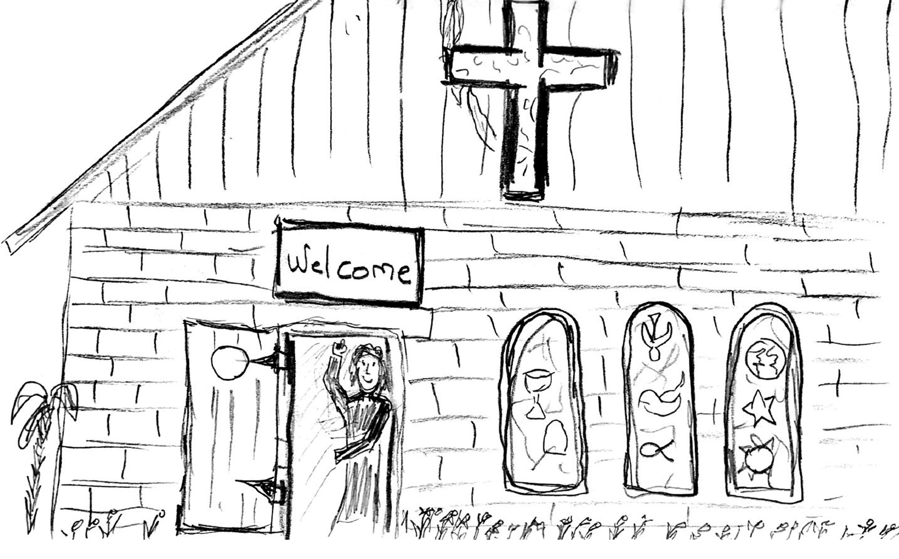

Walls can do great things. Walls hold in the heat during winter and hold up the roof that keeps out the rain. Sometimes people put up walls to keep others away! Signs on those walls might read: “Keep out”, “Private”, “No Trespassing”, or “Members Only.” How do you feel when someone tells you to “keep out”? How do you feel when you you see a “Welcome” sign?

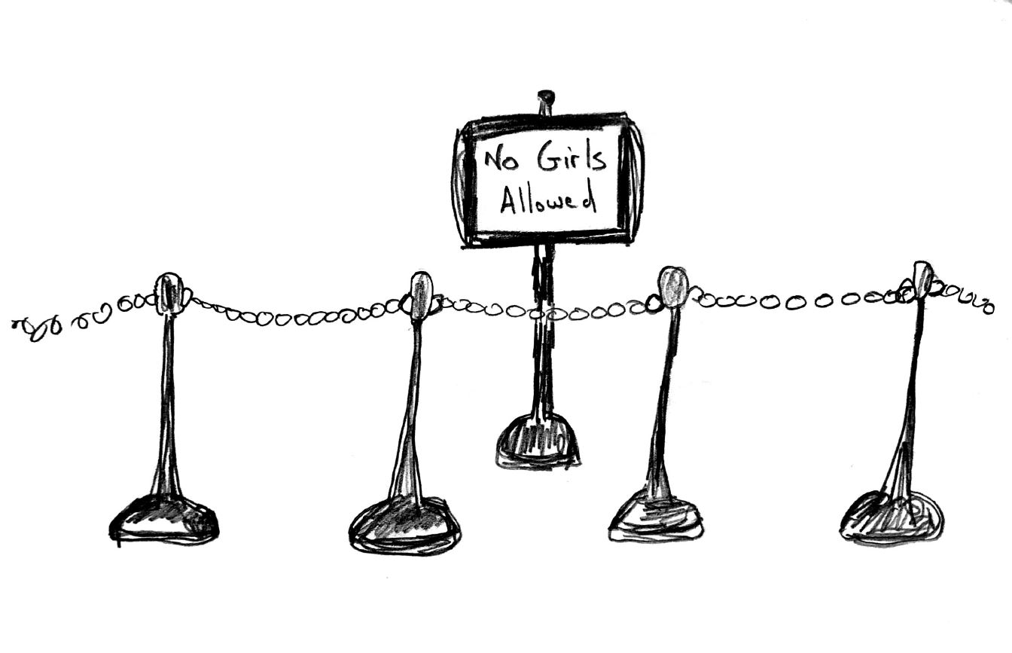

Jesus worshipped in a local synagogue each week. When Jesus was a child, Mary and Joseph took him to the temple in Jerusalem. Every year Jesus went to the temple for special holiday worship services. Sadly, the temple did not welcome everyone. People put up signs telling certain people to keep out. The first sign read, “Israelites Only”. Only people who already belonged to the temple could go inside. The next sign declared: “No Girls Allowed”. Mary, Magdalene, Hannah, and Esther had to stand in the very back of the temple. They looked over a little wall to pray, sing, listen or give an offering. Another sign said, “preachers only”. That sign kept almost everyone out. Finally, there was huge curtain around the Holy Of Holies. Only the the High Priest went inside the curtain, and he went inside only once a year!

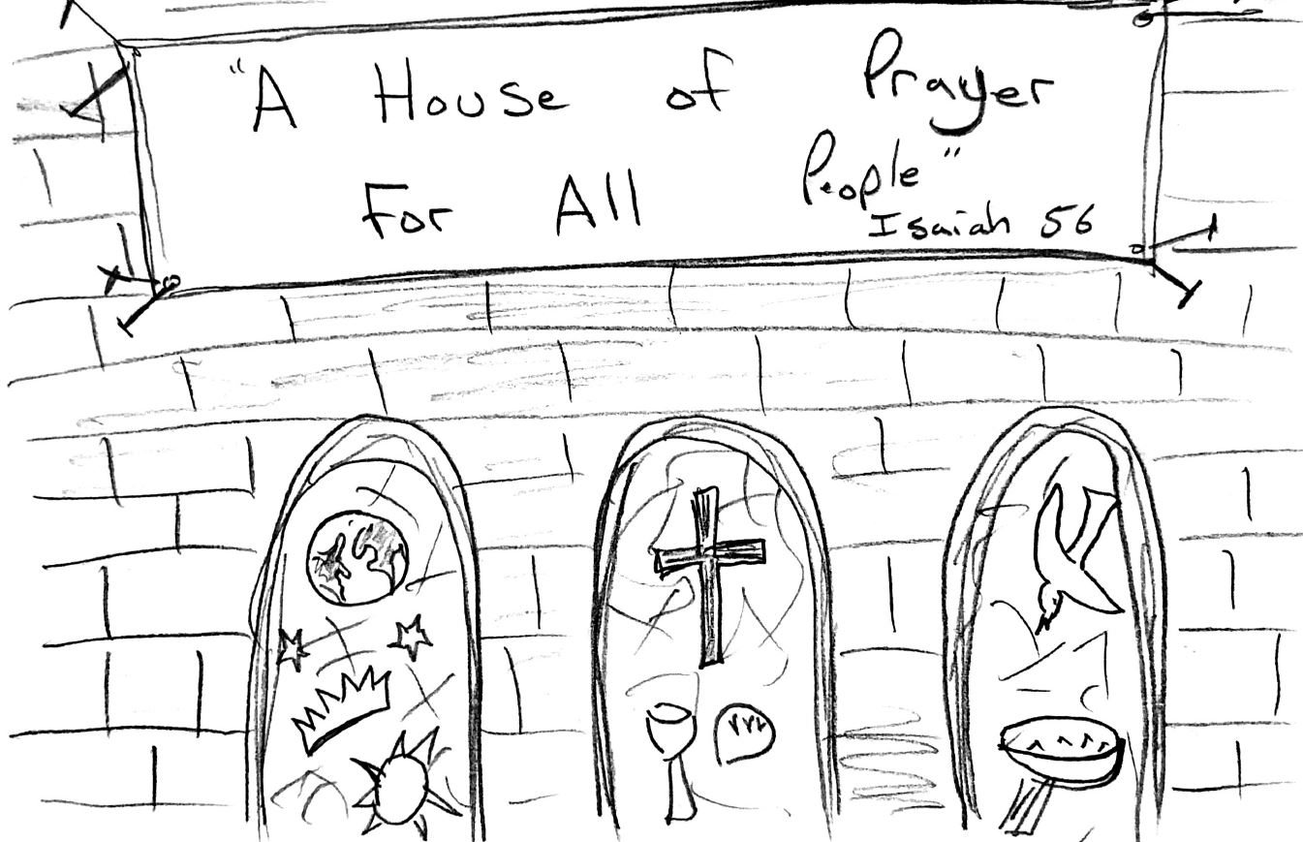
Do you think God likes it when churches tell certain people to keep out? The Prophet Isaiah said, “God’s house should be a place of prayer for all people.” Jesus quoted Isaiah as he led a protest in the temple. In Matthew’s Gospel, at the very moment Jesus dies on the cross, somehow the great big purple curtain keeping people away from the Holy of Holies is torn wide open. The Apostle Paul tells us that when we Jesus’ love guides us, God’s love breaks down any hateful wall inside us.
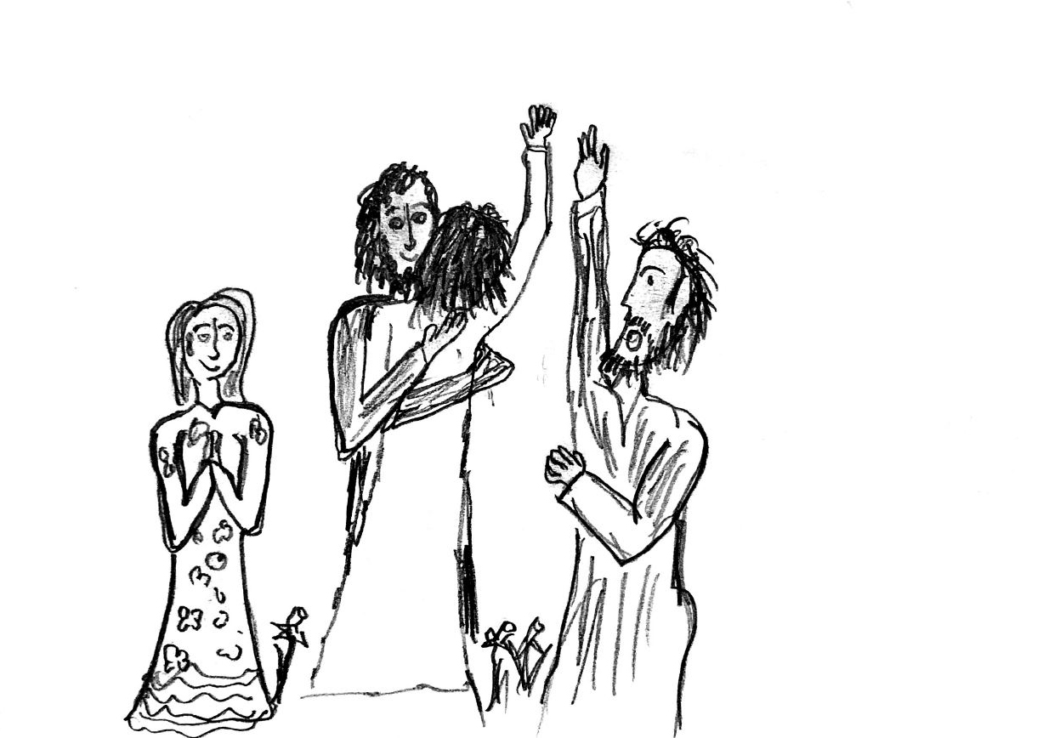
Let’s think about how Jesus made people feel safe and welcomed! In Jesus’ time, many people were afraid of people with a disease called leprosy. Leprosy makes your skin itch and hurt. Afraid of the disease, they made laws forcing people with leprosy to move out of town. Jesus stopped and talked to people with leprosy and broke the rules by even hugging people with leprosy. Jesus brought healing; his love gave sick people hope. Jesus takes down signs saying, ‘no sick people allowed”.

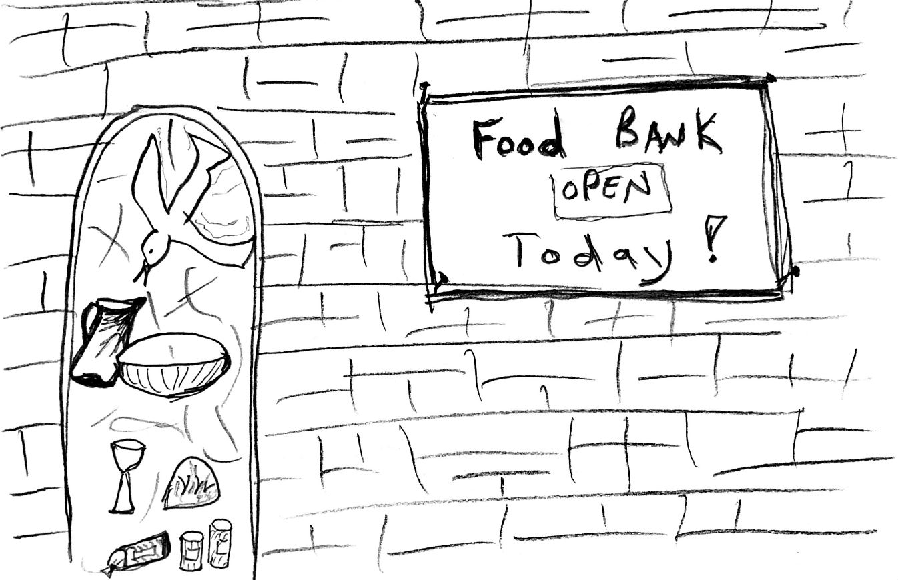

Jesus often ate dinner with rich people, who threw wild and crazy parties. Some church folks said, “Holy people don’t hang out with sinful people like that.” Jesus said, “I did not come to make you churchy people feel good, I came to help hurting people find their way back to God.” Some people like Zacchaeus stopped living to just party and started food banks for hungry people! Jesus gives us hope that we can change and live as God wants us to. Jesus takes down signs saying, “no sinners allowed”.

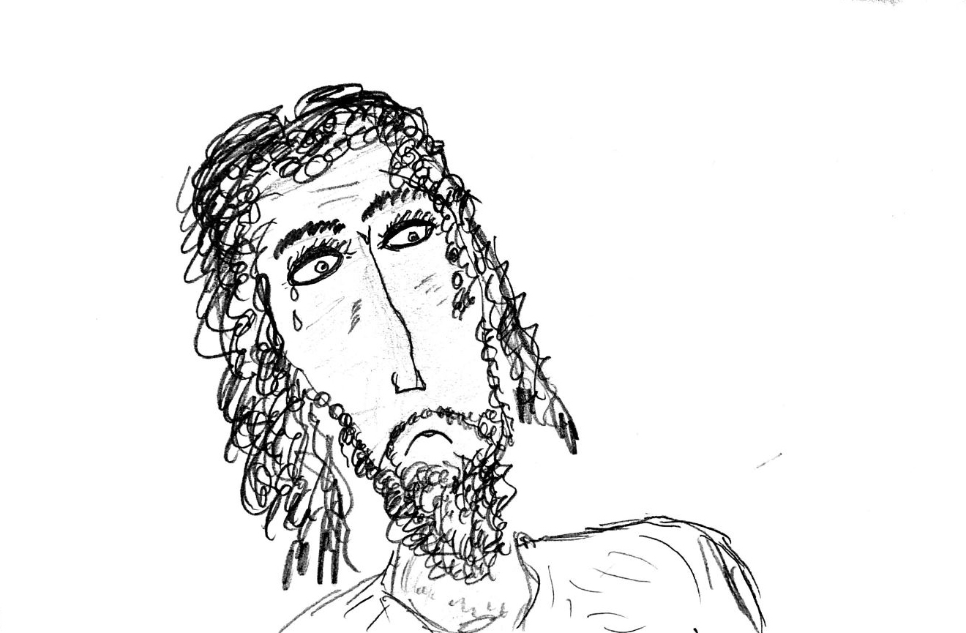
Right after breakfast one morning, Jesus started teaching in the temple that had all those signs. A group of angry preachers dragged a woman to Jesus. Let’s call her Natalie. These preachers somehow caught Natalie doing something they thought was very bad. Like a poster or a prop, they made Natalie stand in her pajamas in front of everyone. They said to Jesus: “Teacher, this woman was caught doing very bad things! The church rules demand she be harshly punished.” Jesus listened to all the mean things they said. Do you think Jesus was frowning as they judged her? Jesus said, “Which one of you has never done something bad?” The crowd looked down, knowing they sometimes did selfish and mean things. Jesus continued, “If you have never messed up, then you punish her!” The crowd trickled away; they knew they had been very mean. Jesus asked Natalie, “Where are all those people who accused you? Did anyone find you guilty?” “No,” Natalie said. Jesus smiled, ”I don’t find you guilty either. Now stop doing things that can hurt you and other people!” Jesus offers us hope, when others put us down or judge us.
Jesus gives us the hope and help we need to do good things!.

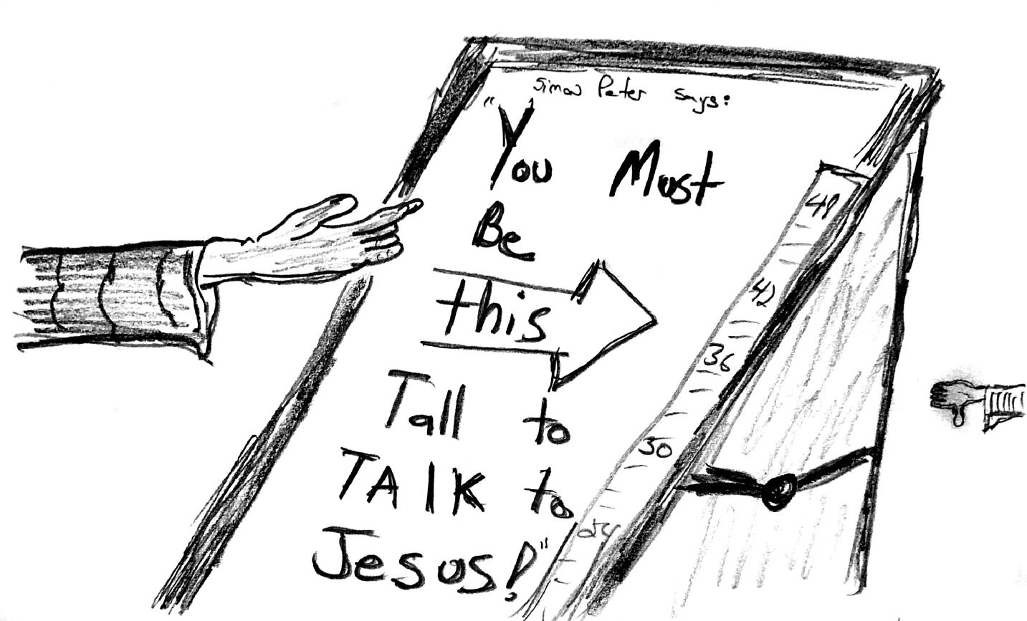

Jesus often spent the whole day teaching and caring for people who were sick or very sad. One day, Jesus was very busy healing people and talking with those asking for help. The house looked like a very busy hospital waiting room. Some parents brought their children to Jesus to ask him to bless their children. Jesus’ disciples told the parents, “Look at all these needy people. Jesus is too busy for children. Jesus needs to spend his time with the grown ups. Get these kids out of here!”

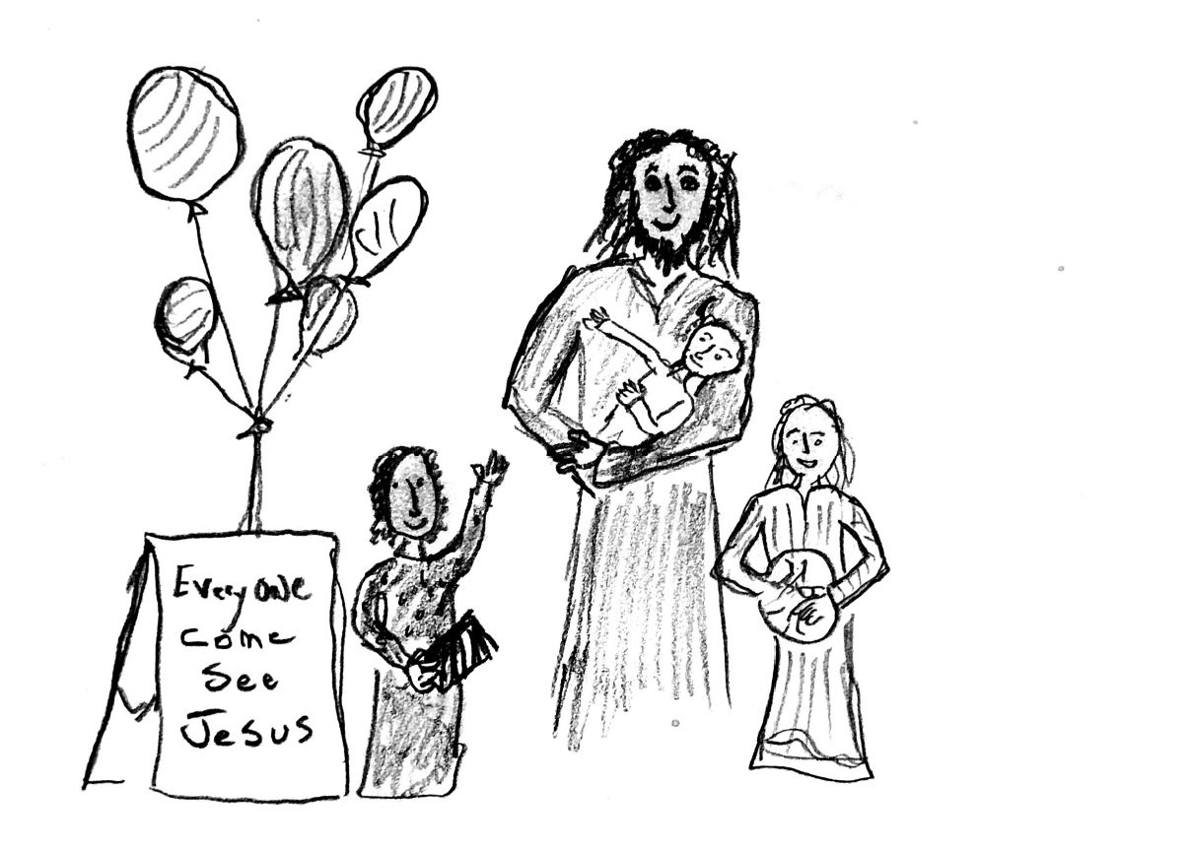
When Jesus heard the disciples saying, “No” to children, Jesus got angry. Why do you think Jesus got mad? Do you think it is okay to be mad sometimes? Jesus corrected his disciples: “Children matter a whole bunch to God! Let all the children come close to God. Let them bring their questions, ideas, and sometimes sticky fingers. Don’t stop anyone who wants to get closer to God. God’s kingdom belongs to everyone who comes with a laugh, a question, a hurt, a joke, a fear, or a hope. In fact, you grown-ups, need to know that everyone must come to God with the same kind of hope, vulnerability, and questions that children bring.” After saying that, Jesus prayed with each child and held the little babies in his arms, whispering sweet little prayers into their ears. Jesus offered hugs, high fives, and loving words to every child and parent.

Jesus has a beautiful way of saying “yes”. I think God wants us to take down our “keep out” signs and make everyone feel welcome. Don’t you always feel hopeful when some makes you feel welcomed?

